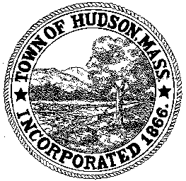

CONSERVATION COMMISSION
78 Main Street, Hudson, MA 01749
(978) 562-2020

Leif Longtine, Chairman David Esteves, Vice Chairman Paul Byrne, Member

David Mercer, Member Joseph Rodrigues, Member Al Tashian, Member W. Minot Wood, Member

Meeting Agenda
December 5, 2013
7:00 P.M.

- Preliminaries
  - Open Meeting
  - Roll Call

2.0 New Business
2.1 RDA 460
Applicant: Ronald Crane
Location: 38 Temi Road
Project Description: Construction of a 16’x32’ garage

2.2 Sam Wong
Discussion on relocation of the Transfer Station

2.3 DEP 190-0568 Request for Certificate of Compliance
Applicant: Thomas Cullen
Location: 61 Brook Street

2.4 DEP 190-0570 Request for Certificate of Compliance
Applicant: John and Kathy Adams
Location: 81 Hunter Avenue

2.4 Request for Review and Comments
10 Old North Road

2.5 Minutes: November 7, 2013

3.0 Old Business
3.1 RDA 440
Update from Historic District Commission

3.2 190-520 (expires 1/19/15)
DPW Blanket Order

4.0 Correspondence

5.0 Adjournment

Next Meeting is December 19, 2013

